|  |  |  |  |  |
| --- | --- | --- | --- | --- |
| **Name** |  | **Score** | **Resource Free** |  |
| **Resource Assisted** |  |
| **Total** |  |

***Attempt all questions and full working out must be shown to get full marks.***

**Total Time: 60 minutes**

* **Section 1 (Calculator Free): 25 minutes 24 marks**
* **Section 2 (Calculator Assisted): 35 minutes 31 marks**

**Calculator Free**

**Question 1 (4 marks)**

Using the unit circle supplied

(a)

(i) find sin θ

sin θ = ____________

ii) draw the other angle with the same value as (i)

θ



(b)

(i) find cos θ

cos θ = ____________

ii) draw the other angle with the same value as (i)

α



**Question 2 (7 marks -1,1,1,1,1,2,)**

1. Convert these angles into degrees:

(i)



(ii)



1. Express these angles in radians
2. 30º
3. 210º
4. State the exact value of sin (2)

­­­­­­­­­

1. Write down the exact values of $sin\left(\frac{2π}{3}\right)$

**­**

Simplify and express with a rational denominator:



**Question 4 (8 marks)**

i) Find *x* in simplified exact form in each of these two diagrams:

a)



1. b)

***x***

***x***

ii) Find θ in each of the following two diagrams.

1. b)

$$6cm$$

$$60\sqrt{3}$$

$$120cm$$



**Question 5 (3 marks)**

The triangle shown below has an area of 36 cm2, determine the value of x.

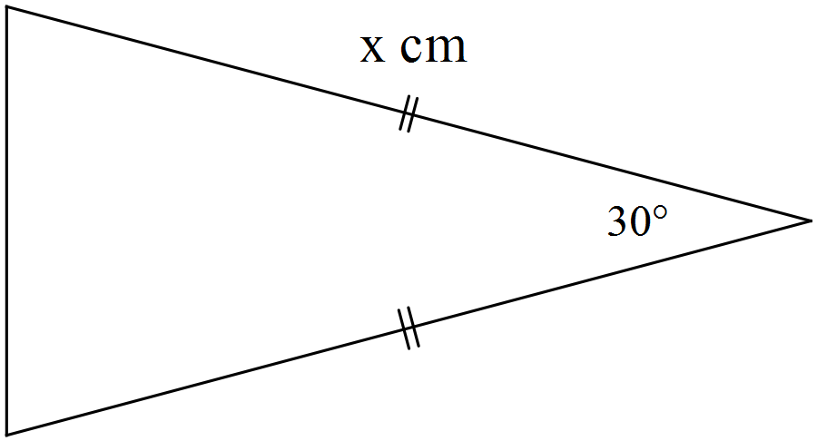

**Calculator Assumed**

**Question 6 (2 marks)**

Determine the equation of the linear function shown below. All values should be expressed in exact form.

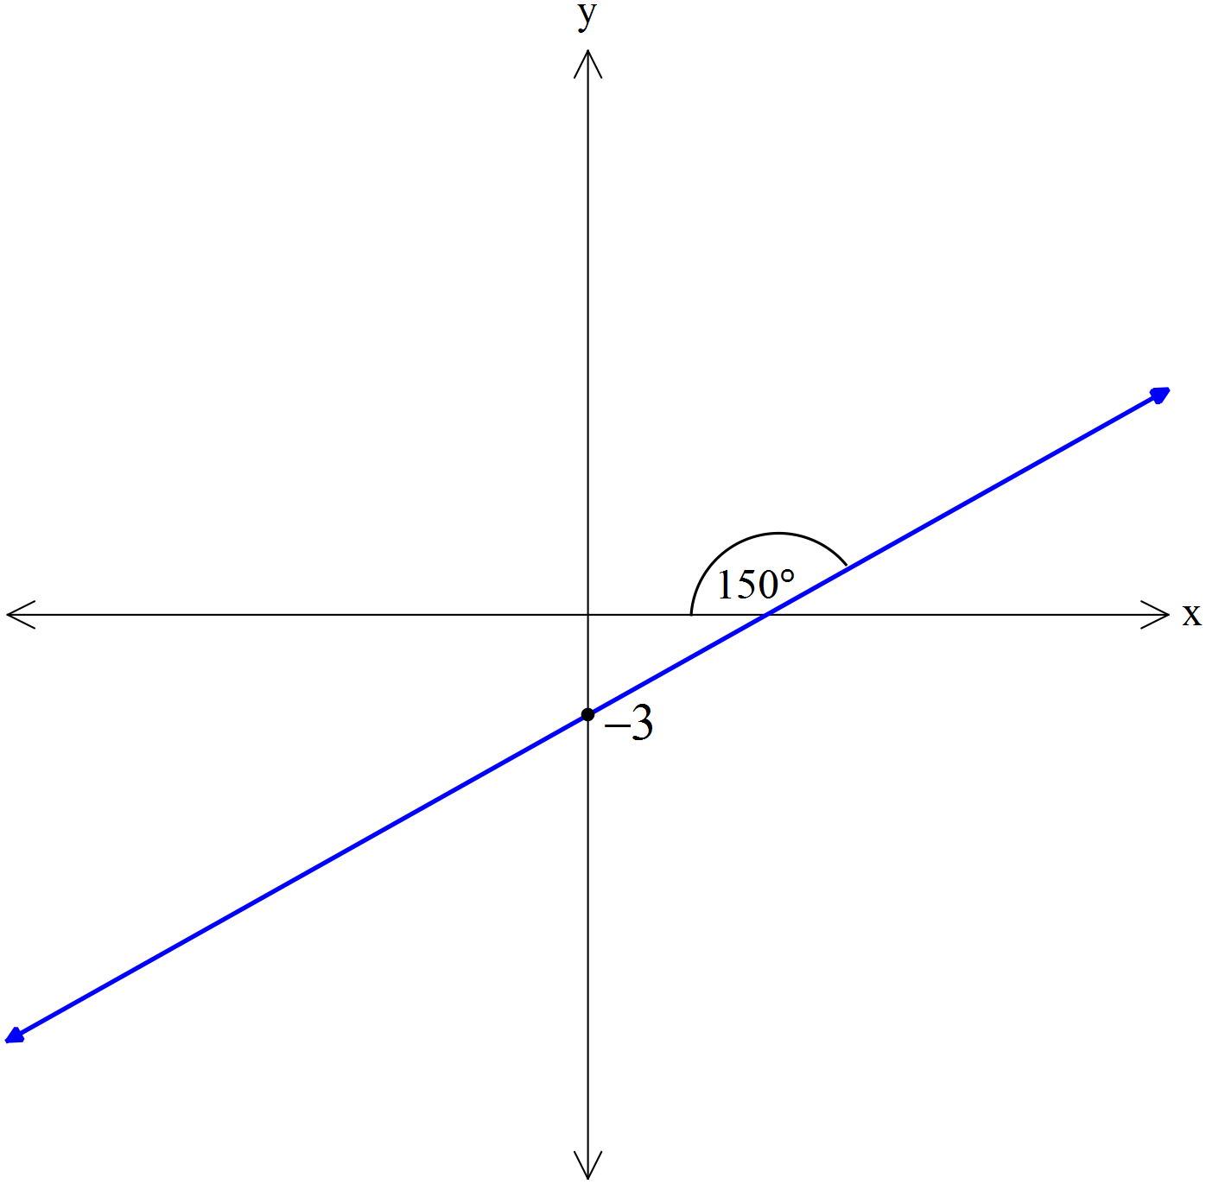

**Question 7 (6 marks)**

Determine, correct to 2 decimal places, the length of side BD in the diagram below.

Note: Diagram not drawn to scale.

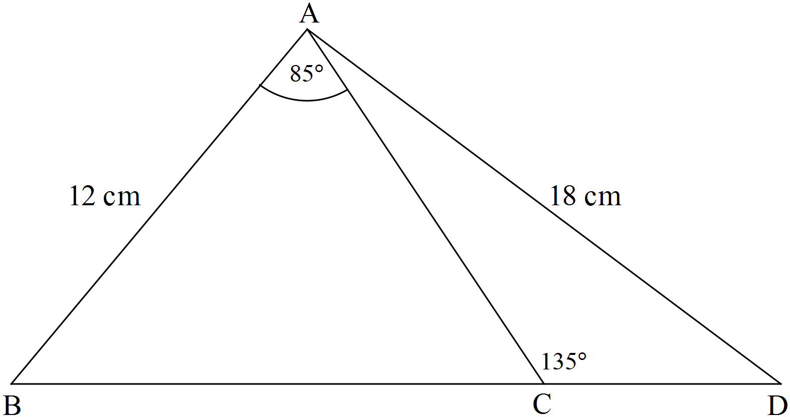

**Question 8 (8 marks)**

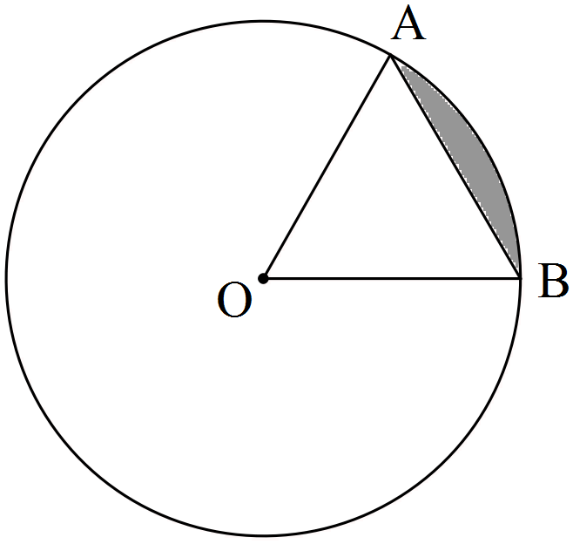The circle shown with centre O has a radius of 3π cm.

If the size of ∠AOB = 60°, determine the

(a) area of triangle AOB as an **exact** value in terms of π.

(b) length of the ***major*** arc AB accurate to 2 decimal places. (2 marks)

(c) area of the ***minor*** sector AOB to the nearest cm2. (2 marks)

(d) area of the ***minor*** segment (shaded) formed by the chord AB accurate to 3 significant figures. (2 marks)

**Question 9 (5 marks)**

Triangle ABC drawn below has sides of 32 cm, 46 cm and 48 cm. The circle with a radius of 11 cm is inscribed inside the circle and just touches the three sides of the triangle.

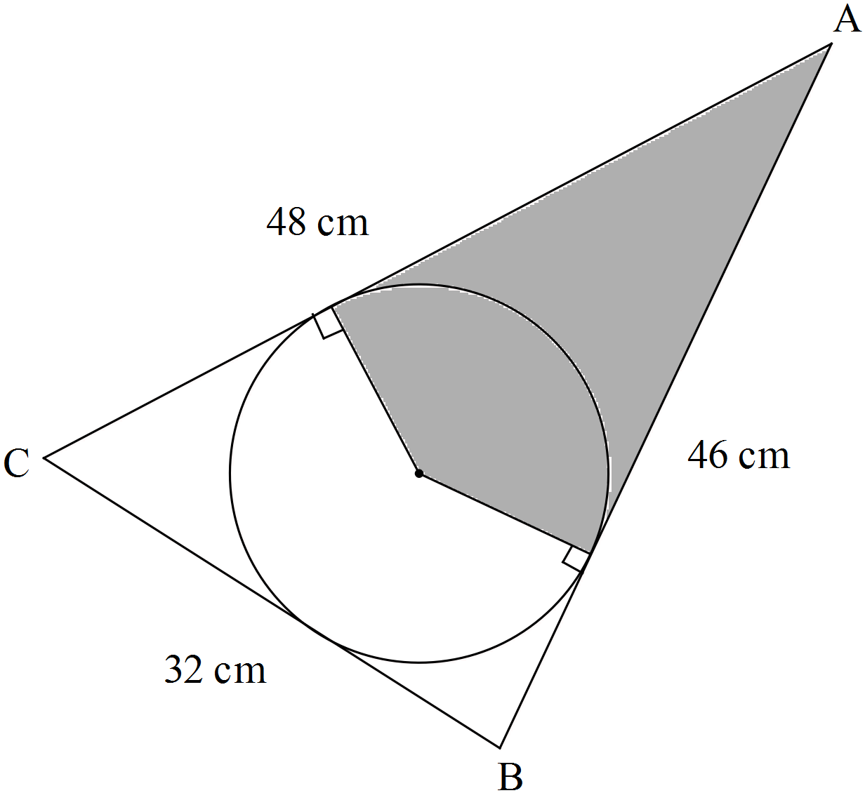

Note: Diagram not drawn to scale.

Determine the area of the shaded region. (Hint: First find the size of ∠BAC).

**Question 10 (10 marks)**

The diagram below shows a pair of intersecting circles with centres at P and Q with radii of 5 cm and 6 cm respectively. RS is the common chord of both circles and PQ is 7 cm.

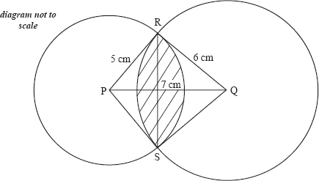

Find the area of the shaded region.

End of Test